

**COURSE NAME :** Software Development II

**DEPARTMENT :** Computer Science and Engineering (CSE)

**COURSE CODE :** CSE 200

**DATE OF SUBMISSION : 24/02/2019**

|  |  |
| --- | --- |
| **Student Name** | **ID No** |
| Swarna Debnath | **16172103083** |
| Sadia Haque | **16172103096** |
| Khoshnur Alam | **16172103101** |
| Md.Mominul Islam | **16172103127** |

Submitted By

Submitted To

Shamim Ahamed

Assistant Professor

Department of CSE

Bangladesh University of Business of Technology (BUBT)

Title: **Library Management System**

ABSTRACT:

Library is place where all kind of books are available. Intranet Library Management system is a web based application. This system contains list of all the books and can be accessed by remote users concurrently from anywhere in the campus. But for that users must be registered user. This system is three tier architecture.

Client sends requests, on receiving the request the server processes it and extracts the data from database and sends the result back to the client. This system provides separate interface and login for librarian, students and faculties. Librarian can modify database.

Users can search for books and renewal books online. They can recommend for new books by just sending messages to the librarian from anywhere in the college. They can view the issue and return dates of any book and due they have to pay. This system generates reports that can be used in analyzing the library performance. Thus the management can take appropriate steps to improve the facilities.

**Declaration:**

We declare that this project and the work presented in it are our own and has been generated by us as the result of our own original research

We confirm that:

* This Work is done wholly or mainly while in candidature for a research degree at this University;
* This project work has not been previously submitted for any degree at this university or any other educational institutes;
* We have quoted from the work of others; the source is always given. With the exception of such quotations, this thesis is entire our own work;

**Declaration**

Dedicated to our parents for all their love and inspiration.

**Acknowledgement**

First of all, we are thankful and expressing our gratefulness to Almighty Allah who offers us His divine blessing, patient, mental and physical strength to complete this project work.

We are deeply indebted to our project supervisor Shamim Ahmed, Assistant Professor, Department of Computer Science and Engineerin(CSE), Bangladesh University of Business and Technology(BUBT). His scholarly guidance, important suggestions, work for going through our drafts and correcting them, and generating courage from the beginning to the end of the research work has made the completion of this thesis possible.

We would like to express our deep gratitude to our Teacher Md.Shamim Reja Sajib, Assistant Professor, Department of Computer Science and Engineering (CSE), Bangladesh University of Business and Technology (BUBT). It was fantastic to get help from him and without his support it will be tough for us to reach the accurate goal.

A very special gratitude goes out to all our friends for their support and help to implement our works. The discussions with them on various topics of our works have been very helpful for us to enrich our knowledge and conception regarding the work.

Last but not the least; we are highly grateful to our parents and family members for supporting us spiritually throughout writing this project and our life in general.

**CERTIFICATE**

This is to certify that Md. Mehadi Hasan, Nusrat Jahan Rakhi and G. M. Shoaibuzzaman students of B.Sc. in CSE have completed their thesis work titled “BMR Encryption System” satisfactorily in partial fulfillment for the requirement of B.Sc.in CSE. Bangladesh University of Business and Technology in the year 2017.

----------------- ------------------- --------------------- ------------------

Sawrna Debnath Sadia Haque Missu Md.Mominul Islam

ID: 16172103083 ID: 16172103096 ID: 16172103101 ID: 16172103127

--------------------------------

Project Supervisor

Shamim Ahmed

(Assistant Professor)

Department of Computer Science and Engineering (CSE)

Bangladesh University of Business and Technology (BUBT)

**Copyright**

© Copyright by Sawrna Debnath(16172103083), Sadia(ID: 16172103096), Missu (ID: 16172103101), Md.Mominul Islam(ID: 16172103127)

All Right Reserved

Index:

|  |  |
| --- | --- |
| SI NO | CONTENTS |
| 01 | Abstract |
| 02 | Introduction |
| 03 | Contribution |
| 04 | Existing System |
| 05 | System analysis of library management system project |
| 06 | SOFTWARE REQUIREMENT SPECIFICATION |
| 07 | PROBLEM STATEMENT |
| 08 | PROJECT AIMS AND OBJECTIVES |
| 09 | PROJECT AIMS AND OBJECTIVES |
| 10 | PROJECT MODULES |
| 11 | System analysis of library management system project |
| 12 | Requirment analysis |
| 13 | Proposed Model |
| 14 | DESCRIPTION OF FEATURE |
| 15 | Output Design |
| 16 | Functional requirements |
| 17 | SOFTWARE AND HARDWARE REQUIREMENTS |

|  |  |
| --- | --- |
| 18 | PROJECT MODULES |
| 19 | Advantages |
| 20 | System requirement |
| 21 | Software requirement |
| 22 | SOFTWARE TOOLS USED |
| 23 | BACK END |
| 24 | DATA FLOW DIAGRAMS |
| 25 | SYSTEM TESTING |
| 26 | UNIT TESTING |
| 27 | INTEGRATION TESTING |
| 28 | History of Open Source and Free Software |
| 29 | Defining Open Source |
| 30 | Definition |
| 31 | Basic Characteristics of Open Source |
| 32 | Study Design |
| 33 | Study period |
| 34 | Future Work Extension |
| 35 | CONCLUSION |
| 36 | References |
| 37 | Sources of Data |

Introduction:

Library management is a sub-discipline of institutional management that focuses on specific issues faced by libraries and library management professionals. Library management encompasses normal managerial tasks, as well as intellectual freedom and fundraising responsibilities. Issues faced in library management frequently overlap with those faced in managing non-profit organizations.The basic functions of library management include, but are not limited to: planning and negotiating the acquisition of materials, Interlibrary Loan requests, stacks maintenance, overseeing fee collection, event planning, fundraising, and human resources.

A college library management is a project that manages and stores books information electronically according to student needs. The system helps both students and library manager to keep a constant track of all the books available in the library. It allows both the admin and the student to search for the desired book. It becomes necessary for colleges to keep a continuous check on the books issued and returned and even calculate fine. This task if carried out manually will be tedious and includes chances of mistakes. These errors are avoided by allowing the system to keep track of information such as issue date, last date to return the book and even fine information and thus there is no need to keep manual track of this information which thereby avoids chances of mistakes. Thus this system reduces manual work to a great extent allows smooth flow of library activities by removing chances of errors in the details.

**Contribution**

Library Management System is a software application to manage all the activities concern to the library. This project will help the education organization to store all library related information. This application is useful store all the information of a book.This application software provide the live commentary of a librean. If there has no television then the people will know the update of the library management .It is the main purpose of this software.

**Existing System**

        The existing libreary management system of watching book details is generally on the soft wear. Most books are not scheduled on borrow and this will allow people access to the book regardless of their location. Some sites do exist that display text commentary but they are very impersonal.

System analysis of library management system project

we will discuss and analyze about the developing process of Library Management System including software requirement specification (SRS) and comparison between existing and proposed system . The functional and non functional requirements are included in SRS part to provide complete description and overview of system requirement before the developing process is carried out. Besides that, existing vs proposed provides a view of how the proposed system will be more efficient than the existing one.

Existing System:

Various problems of physical system are described below:-

· If one is not very careful then there is a possibility of issuing more than one book to a user.

· There is a possibility of issuing a book to a user, whose membership is not there.

· When a user requests for the a book, one has to physically check for the presence of a book in the library

· Answering management query is a time consuming process.

· Daily keeping a manual record of changes taking place in the library such as book being issued, book being returned etc can become cumbersome if the Library size is bigger.

2. Proposed System:

The LIBRARY MANAGEMENT SYSTEM is a software application which avoids more manual hours in taking the book, that need to spend in record keeping and generating reports. Maintaining of user details is complex in manual system in terms of agreements, royalty and activities. This all have to be maintained in ledgers or books. Co-coordinators needs to verify each record for small information also.

· Easy search of book in the online library.

· Avoid the manual work.

· User need not go to the library for Issue any kind of book, he can renewal the book online.

SOFTWARE REQUIREMENT SPECIFICATION

GENERAL DESCRIPTION PRODUCT DESCRIPTION:

Library Management System is a computerized system which helps user(librarian) to manage the library daily activity in electronic format. It reduces the risk of paper work such as file lost, file damaged and time consuming. It can help user to manage the transaction or record more effectively and timesaving.

PROBLEM STATEMENT:

The problem occurred before having computerized system includes:

• File lost When computerized system is not implemented file is always lost because of human environment.Some times due to some human error there may be a loss of records.

• File damaged When a computerized system is not there file is always lost due to some accdent like spilling of water by some member on file accidentally.Besides some natural disaster like floods or fires may also damage the files

• Difficult to search record When there is no computerized system there is always a difficulty in searching of records if the records are large in number.

• Space consuming After the number of records become large the space for physical storage of file and records also increases if no computerized system is implemented.

• Cost consuming as there is no computerized system the to add each record paper will be needed which will increase the cost for the management of library.

**PROJECT AIMS AND OBJECTIVES**:  
  
  
1. Online book issue. Improvement in control and performance   
  
2. Request column for librarian for providing new books. The system is developed to cope up with the current issues and problems of library .The system can add user, validate user.  
  
3. A separate column for digital library. Librarian is able to search record by using few clicks of mouse and few search keywords thus saving his valuable time.   
  
4. Student login page where student can find books issued by him/her and date of return. After computerized system is implemented less human force will be required to maintain the library thus reducing the overall cost. A search column to search availability of books. A teacher login page where teacher can add any events being organized in the college and important suggestions regarding books.

**Proposed Model**

**Requirment analysis**

The proposed libreary management system will allow people to stream the borrow book and read text based books details as well, while we use this program viewing a digital worksope with librean. The commentary will be available post the book as well for review.

SYSTEM REQUIREMENTS

NON FUNCTIONAL REQUIREMENTS

• Product Requirements

EFFICIENCY REQUIREMENT When a library management system will be implemented librarian and user will easily acess library as searching and book transaction will be very faster .

RELIABILITY REQUIREMENT

The system should accurately performs member registration ,member validation , report generation, book transaction and search

USABILITY REQUIREMENT

The system is designed for a user friendly environment so that student and staff of library can perform the various tasks easily and in an effective way.

ORGANIZATIONAL REQUIREMENT

IMPLEMENTATION REQUIREMNTS

In implementing whole system it uses html in front end with php as server side scripting language which will be used for database connectivity and the backend ie the database part is developed using mysql.

DELIVERY REQUIREMENTS

The whole system is expected to be delivered in six months of time with a weekly evaluation by the project guide.

SEARCH BOOK

DESCRIPTION OF FEATURE

This feature is found in book maintenance part .

we can search book based on book id , book name , publication or by author name.

Functional requirements

- System must be able to search the database based on select search type

- System must be able to filter book based on keyword enterd

- System must be able to show the filtered book in table view.

Output Design

Front page:

This is starting page .

There have

* Student
* Librearian
* Close Application

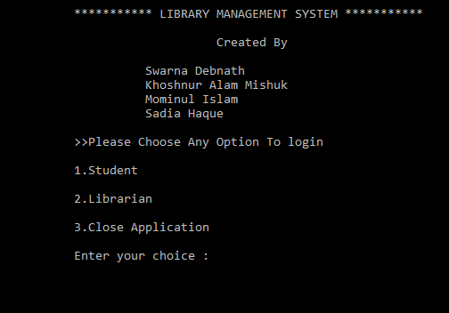

Student:

Thios process we show

* View book list
* Search for a book
* Go to main manue
* Close Application

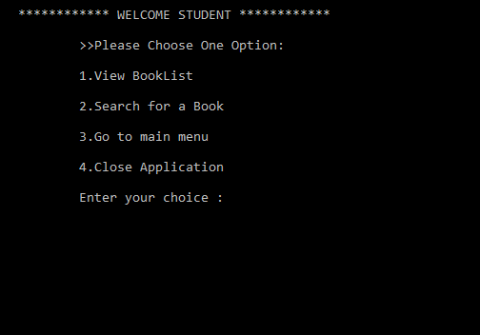

View book list:

This process we view book list and details of book.

There are many types of book

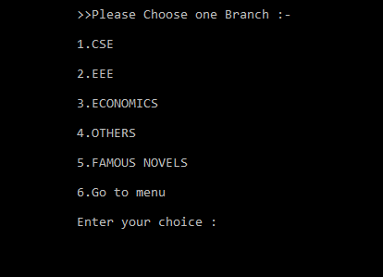

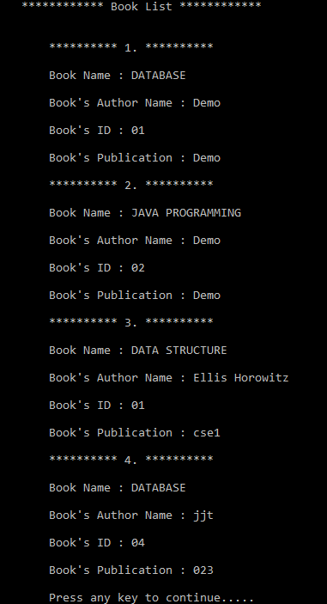

Search for book:

This process we search book in book list.

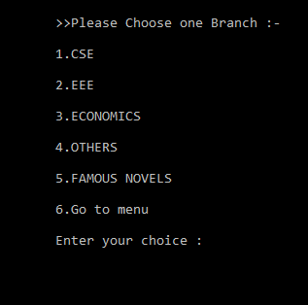

Librarian:

Librearian is work official in this process.

This process works on

* View book list
* Search book
* Add book
* Issue book
* Change password

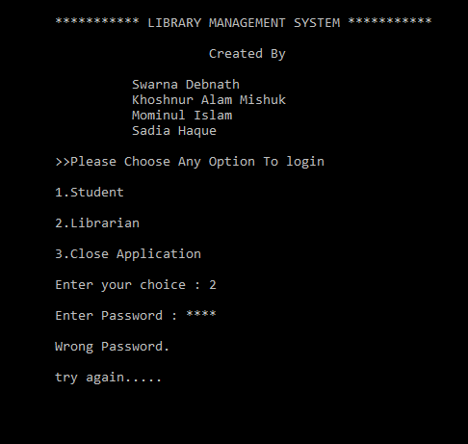

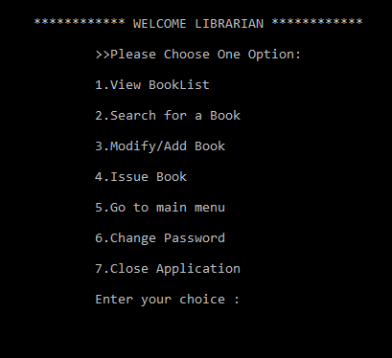

Modify for a book:

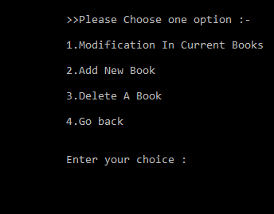

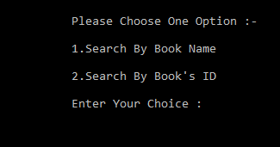

Add new book:



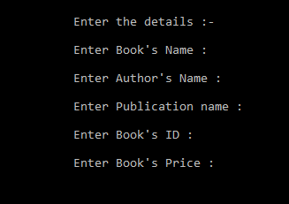

Delete a book:



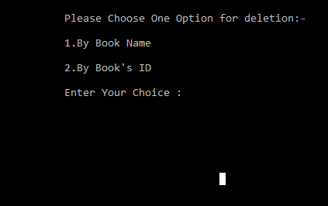

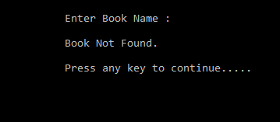

Issue Book:



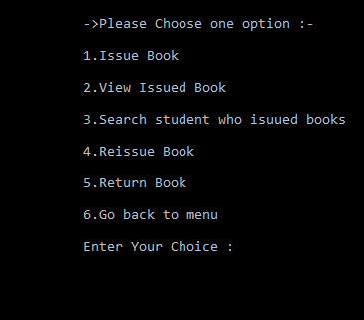

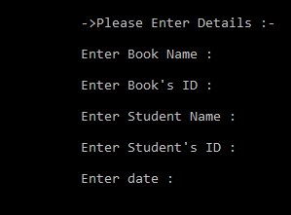

View issue book:

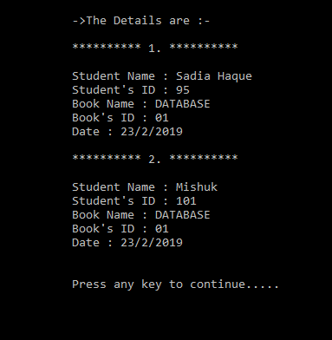

Who Issue book:

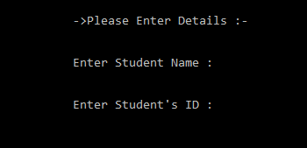

Reissue book:



Return Book:



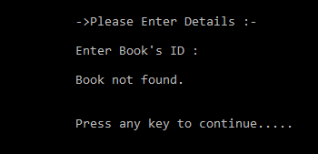

Change Password:

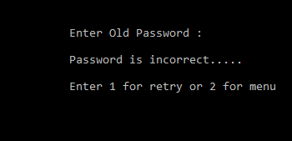

This feature allows to issue and return books and also view reports of book issued.

Functional requirements

-System must be able to enter issue information in database.

-System must be able to update number of books.

- System must be able to search if book is available or not before issuing books -System should be able to enter issue and return date information

DESCRIPTION OF FEATURE

This feature allows teacher and student to add information about various workshops being conducted in college and colleges nearby.

-System should be able to add detailed information about events .

-System should be able to display information on notice board available in the homepage of site.

SOFTWARE AND HARDWARE REQUIREMENTS

This section describes the software and hardware requirements of the system SOFTWARE REQUIREMENTS

• Operating system- Windows 7 is used as the operating system as it is stable and supports more features and is more user friendly

• Database MYSQL-MYSQL is used as database as it easy to maintain and retrieve records by simple queries which are in English language which are easy to understand and easy to write.

HARDWARE REQUIREMENTS

¬ Intel core i5 2nd generation is used as a processor because it is fast than other processors an provide reliable and stable and we can run our pc for longtime. By using this processor we can keep on developing our project without any worries.

¬ Ram 1 gb is used as it will provide fast reading and writing capabilities and will in turn support in processing.

**Advantages**

* Manage the complete management of the entire library through the software’s easy interface.
* It removes manual process of issuing books by easy and simplified way of issuing book saving time and effort
* The librarian can issue, return and reserve book for a particular student through the software’s interface
* The software automatically shows fine levied by automatically counting days from the date if issue incase of late return of the book
* Add, update, search and view library items online
* Student can also check the availability status of a particular book online
* Generate customized report for library items, library inventory and library fine collection

System requirement

Processor : Intel Dual core 1.5 GH or more

RAM : 2 GB

Hard-Disk: 2 GB

**Software requirement:**

Operating system :

* windows operating system
* C++

SOFTWARE TOOLS USED

The whole Project is divided in two parts the front end and the back end.

BACK END

- The back end is designed using mysql which is used to design the databases

It is a 2nd level Data Flow Diagram where after entering STUDENT LOGIN page he/she can select a book issue option where after entering the book detail, he/she can select the book issue option and if the maximum no of books issued limit is not crossed then a request will be sent to the librarian who will approve the book issue.

SYSTEM TESTING

The aim of the system testing process was to determine all defects in our project .The program was subjected to a set of test inputs and various observations were made and based on these observations it will be decided whether the program behaves as expected or not. Our Project went through two levels of testing

1 .Unit testing

2 .integration testing

UNIT TESTING

Unit testing is undertaken when a module has been created and succesfully reviewed .In order to test a single module we need to provide a complete environment ie besides the module we would require

• The procedures belonging to other modules that the module under test calls

• Non local data structures that module accesses

• A procedure to call the functions of the module under test with appropriate parameters Unit testing was done on each and every module that is described under module description of chapter.

1.Test For the admin module

• Testing admin login form-This form is used for log in of administrator of the system.In this we enter the username and password if both are correct administration page will open other wise if any of data is wrong it will get redirected back to the login page and again ask for username and password

• Student account addition- In this section the admin can verify student details from student academinc info and then only add student details to main library database it contains add and delete buttons if user click add button data will be added to student database and if he clicks delete button the student data will be deleted

• Book Addition- Admin can enter details of book and can add the details to the main book table also he can view the books requests .

2. Test for Student login module

• Test for Student login Form-This form is used for log in of Student .In this we enter thelibraryid, username and password if all these are correct student login page will open other wise if any of data is wrong it will get redirected back to the login page and again ask for libraryid, username and password.

• Test for account creation- This form is used for new account creation when student does not fill the form completely it asks again to fill the whole form when he fill the form fully it gets redirected to page which show waiting for conformation message as his data will be only added by administrator after verification.

3. Test for teacher login module-

• Test for teacher login form- This form is used for logg in of teacher .In this we enter the username and password if all these are correct teacher login page will open other wise if any of data is wrong it will get redirected back to the login page and again ask for username and password.

INTEGRATION TESTING

In this type of testing we test various integration of the project module by providing the input .The primary objective is to test the module interfaces in order to ensure that no errors are occurring when one module invokes the other module.

History of Open Source and Free Software:

The concept of open source and the free sharing of technological information existed long before

computers. For example, cooking recipes have been shared since the beginning of human culture.

Open source first evolved during the 1970s. Richard Stallman, an American software developer

who believes that sharing source-code and ideas is fundamental to freedom of speech, developed

a ‘free’ version of the widely used ‘Unix’ operating system. The resulting ‘GNU’ program was

released under a specially created General Public License (‘GNU GPL’). This was designed to

ensure that the source-code would remain openly available to all. It was not intended to prevent .

commercial usage or distribution. This approach was named ‘free software’. In this context ‘free’

meant that anyone could modify the software. However, the term ‘free’ was often misunderstood

to mean ‘no cost’. Hence ‘open source software’ was coined as a less contentious and more

‘business-friendly’ term.

Defining Open Source:

Open-source software is software whose source code is published and made available to the

public, enabling anyone to copy, modify and redistribute the source code without paying

royalties or fees. Open source code can evolve through community cooperation. These

communities are composed of individual programmers or group of individuals as well as very

large companies.

Definition:

There are numerous groups, who claim ownership of the term "Open Source", but the term has

not been trademarked. The Open Source Initiative's definition is widely recognized as the

standard or de facto definition. The common definition should be:

"Open source promotes software reliability and quality by supporting independent

peer review and rapid evolution of source code. To be certified as open source, the

license of a program must guarantee the right to read, redistribute, modify, and use

it freely"

Basic Characteristics of Open Source:

OSS has many characteristics. The important ones are:

1. It is generally acquired or downloaded freely

2. Manufacturer, developer or designer has no right to claim royalties on the distribution or

use

3. Source code is accessible to the user and distributed with the software iv) No denial to an

individual or to a group to access source code of the software

4. It has provision of modifications and derivations under the programme’s original name

5. Rights of facilities attached to the programme must not depend on the programme’s being

part of a particular software distribution

6. Licensed software cannot place restriction on other software that is distributed with it

7. Distribution of license should not be specific to a product and License should be

technology neutral, etc.

Open Source Software a Collective Action:

0The Philosophy of Open Source Software is extremely simple: When anyone allowed

working freely on the source code of a programme, this will inevitably improved because

collaboration helps to correct errors. Community contribution is a key to live any open source

distribution. Less the contribution means less the life for OSS.

Study Design

* Input design:

Input design is the process of converting user oriented input to a computer based format. Input Design is a part of overall designs, which requires very careful

Attention .Often the collection of input data is the most expensive parts of system.

The main objective of input design:

1. Product cost effective method of input
2. Achieve highest possible level of accurency
3. Ensure that the input acceptable to and understood by the self

**Study period**

|  |  |  |
| --- | --- | --- |
| SL.No | **Duration** | **Work Title** |
| **1** | 24/12/18 | Planning Program |
| 2 | 01/01/19 | Planning Program |
| **3** | 07/01/19 | Create Database Table |
| **4** | 15/01/19 | C++ code implement |
| **5** | 24/01/19 | Create Presentation Slide |
| **6** | 12/02/19 | Flowing all process |

**Future Work Extension**

This application can be used in institute. So through out the country this program is very useful. Also this program helps the organizer to store data in digital form.

CONCLUSION:

The package was designed in such a way that future modifications can be done easily. The following conclusions can be deduced from the development of the project.

* Library Management System of the entire system improves the efficiency.
* It provides a friendly graphical user interface which proves to be better when compared to the existing system.
* It gives appropriate access to the authorized users depending on their permissions.
* It effectively overcomes the delay in communications.
* Updating of information becomes so easier.
* System security, data security and reliability are the striking features.
* The System has adequate scope for modification in future if it is necessary.

References:

* "The Journal of Library Administration". Retrieved 7 November 2013. McClure, C. R. (1980).
* "LIBRARY MANAGERS: Can They Manage? Will They Lead?". Library Journal: 2391.
* Sharma, C. K.; Singh, Kiran (2005)
* Westman, Stephen R., Creating Database-Backend Library Web Pages: Using Open
* Source Tools, Ess Ess Pub., 2009
* Amin, Saiful, Open Source Software for Libraries, A Trend Report, DRTC, Banglore
* 2003
* Hasan, Nabi, Issues and Challenges in Open Source Software Environment with Special
* Reference to India, CSK H. P. Agricultural University, Palampur (HP), India
* Sangsuree Vasupongayya, Kittisak Keawneam, Kittipong Sengloilaun, Patt Emmawat:
* Open Source Library Management System Software: A Review, Hat Yai, Songkhla,

## Sources of Data

* htpps:/www.wikipedia.com/library management
* htpps:/www.google.com/library management
* http://dspace.cusat.ac.in/jspui/bitstream/123456789/8218/1/library%20management%20system.pdf